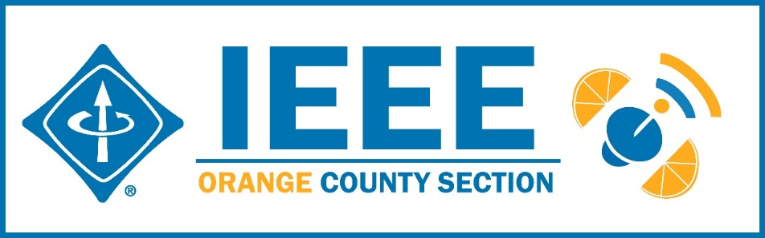
Agenda – IEEE Orange County Section Executive Committee Meeting
DATE: | Thursday 9-10-2020
TIME: | 6:30 PM – 8:30 PM
LOCATION: | On-line

- Networking 6:00pm-6:30pm
  - Meet-n-greet / Food on your own / Sign-in -
- Call Meeting to Order – 6:30pm
  - Secretary Quorum Status – Secretary Attendees: 12 Members, 1 Guests
  - Groups represented: YP, CS, Nano, PSES, GameSIG, Chapman, CyberSIG, EMBS, SPS/VTS
  - Introduction of attendees (if time permits) –
  - Approve Minutes from previous month(s) – Donr
http://sites.ieee.org/ocs/section-meeting-minutes/
  - Approve Agenda – Done
- Section Business
  - Chairman’s opening remarks –
  - 2021 Goals statement:
  - Follow up Action Items from last meeting(s)
    - Gora to regularly highlight chapters who have not reported –
    - Sponsor package –
    - Reminder to file L31 & financial reports –
    - Gora planning IEEE tools training on line periodically.- Next one 10/14. Recently gave training to Foothill Section Officers including students.
    - IEEE offers Membership Development Webinars that are worth attending to improve chapter operations.

  - Treasurer’s report
    - Section Ledger – IEEE Rebates distribution underway - Deferred
    - Outstanding Funding Requests –
    - New OC Section logo bumper stickers 1 3/8”x 5” available now – send Nick your mailing address
  - Awards Chair
    - IEEE Region 6 Awards - Call for Nominations. Inviting all members to review and submit nominations for the IEEE Region 6 Awards.
https://ieee-region6.org/2020/call-for-nominations-ieee-region-6-awards-now-open/
Send nominations to Vice Chair, Alberto.
Categories can be Corporate Service, Student Branch, Outstanding Engineer, Best Chapter,… Deadline is Sept 30 but please do before.
A.I.- Get our chapters to apply - just need a list of events

- Event Updates (Check www.e-lynx.org or search the web for the event or click the link for more info)
  - IEEE Day – Nathan at UCI to hold a panel October 6,, requesting participants to say why they love the IEEE, how they progressed in their career,…An e-Lynx note invitation got a lot of responses from members willing to participate.
  - IEEE Sections Congress –Vice Chair Alberto to vote on behalf of the Section.
First sessions held Sept 1, 2. Next on 9/15.
  - Sustech conf update: ** Planning for 2021 Sustech is in early stages – this may be an OC spearheaded event and volunteers are needed to participate. MOU approved. Organizing committee meets 5PM every Friday – join in. Contact Gora
Motion made and approved to allocate $1000 in support of Sustech.
  - 2020 IEEE Elections start 8/17 and end 10/1.
https://www.ieee.org/about/corporate/election/index.html

- OC Section and Committee Reports
  - Membership Development (MD) –– NEED an active person
It was suggested to have a “Life Members cameo region on the section website and solicit submissions from the sections’s Life Members.
  - Corporate Relations – Michael Fahey –
Michael reported studying the Santa Clara Valley IEEE Corporate Liaison model and advocated for a revamped website in order to project a professional image to potential corporate partners. This is a necessary first step. Then holding quarterly or other regular events with an economic aspect related to tech topics – e.g., tech and economic side of privacy.
Motion made and approved to engage Russell to revamp the IEEE OC Section website with the alternate more modern theme. Mike to provide in advance suggested layouts and trees.
  - Educational Activities – Kumar
  - STEM Initiatives – .Kumar –
  - Web events calendar www.e-lynx.org – Advertiser / Distribution updates – Nick- current advertisers include: ETAP 2020, IEEE TECH TALK Banner – Podcasts from IEEE experts. Manufacturing Show. K & S paid Job “ad” event through Sept 1.

- University Student Branch Report
  - California State University Fullerton (CSUF) –
  - University of California, Irvine (UCI) – Nathan
  - Chapman University – Brandon reported the chapter is doing well. They have a website that has been the avenue for new members to join in.

- Affinity Groups
  - Women in Engineering (WiE) –
  - Young Professionals (YP) – Irvin / Fred Lawler
Proposed Fall ‘Kickoff’ YP Event
Format: Interactive Talk, Demo, Q&A & Raffle
Date/Time: TBD, 7pm to 8:30pm (via ZOOM)
ExCom committed to $100 support for raffle or as needed
  - CyberSecurity SIG – (Gora)
  - GameSIG -

- OC Chapters & Society Activities
  - Aerospace & Electronics Systems Society (AESS) – Dormant
  - Communications Society /Signal Processing Society-Jt. VTS (COMSIG) / VTS – Kay The Connected Vehicle Newsletter ver. 10 just published . Gora suggests folding all the reports into some other venue and also enhancing the website presence. https://site.ieee.org/ocs/
  - Computer Society (CS) – Shirley/Winsor – IEEE CS / ACM meets Wednesday – Future topics ara Connected Vehicles, Data Networking, Analytics Data Science
  - Electromagnetic Compatibility Society (EMC) –
  - Engineering in Medicine and Biology Society (EMBS) – Gora -.4th Monday events – Most recent event on 8/21 – Medical Devices speaker. Has been recorded.
  - Microwave Theory Tech / Electron Dev Jt Society(MTT/ED) –
  - Joint Foothill/OC Sections Nanotechnology Council Chapter – Nick – Working on line in Oct. since students are on-line this school year.
  - Power and Energy Society/Industry Applications Society (PES/IAS) –
  - Product Safety Engineering Society (PSES) – Paul - 4th Tuesday events continuing on-line via Zoom. More of the same in planning.
  - Robotics & Automation Society (RAS) -Dormant
  - Solid State Circuits – Dormant
  - LMAG –

- IEEE National, Region, & Council Updates
  - IEEE Southern California Council (ISC2) – UPDATE----
    - IEEE “TECH Talks” Speaker Forum – Gora – Conference in the works: Healthcare Blockchain& AI. 12 independent blocks with separate themes stretched over 12 months.
    - IEEE USA Gov’t Relations Committee – Working on platform for Government Agencies and Contractors to collaborate. Also student volunteer effort kicked off – MingYuan Wu involved somehow.
    - AB5 – It was reported that now a sole proprietorship consultant is exempt from AB5.
    - A larger funding proposal (from IEEE) is in process
  - IEEE MGA / TAB coming up with “Local Group” facility

- New Business
  - New Funding Requests –
**
NEXT MEETTING – October 8, 2020

