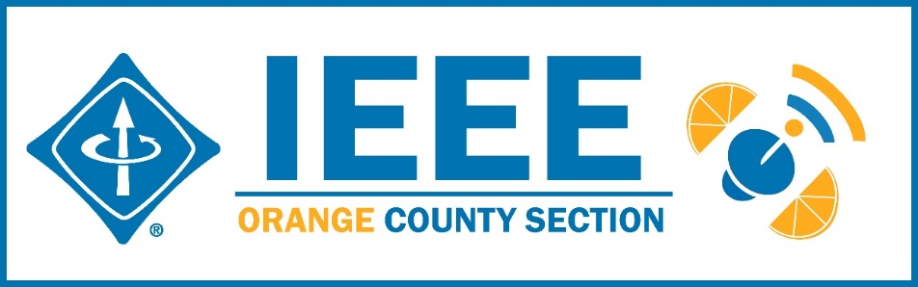
Minutes – IEEE Orange County Section Executive Committee Meeting
DATE: | Thursday 8-13-2020
TIME: | 6:30 PM – 8:30 PM
LOCATION: | On-line

- Networking 6:00pm-6:30pm
  - Meet-n-greet / Food on your own / Sign-in -
- Call Meeting to Order – 6:30pm
  - Secretary Quorum Status – Secretary 17 Attendees: Members, 1 Guests
  - Groups represented: YPs, CS, Nano, EMBS, PES, UCI, VTS, Chapman?
  - Introduction of attendees (if time permits) – ok
  - Approve Minutes from previous month(s) – Done
http://sites.ieee.org/ocs/section-meeting-minutes/
  - Approve Agenda – Approved
- Section Business
  - Chairman’s opening remarks –
  - 2021 Goals statement:
  - Follow up Action Items from last meeting(s)
    - Gora to regularly highlight chapters who have not reported –
    - Sponsor package –
    - Reminder to file L31 & financial reports –
    - Gora planning IEEE tools training on line periodically.
    - IEEE offers Membership Development Webinars that are worth attending to improve chapter operations.
    - What on line seminar services are available and in use in OC Section?

  - Treasurer’s report
    - Section Ledger – IEEE Rebates distribution underway - Deferred
    - Outstanding Funding Requests –
    - New OC Section logo bumper stickers 3”x 5” available now – send Nick your mailing address
  - Awards Chair
    - IEEE Region 6 Awards - Call for Nominations. Inviting all members to review and submit nominations for the IEEE Region 6 Awards.
https://ieee-region6.org/2020/call-for-nominations-ieee-region-6-awards-now-open/
Send nominations to Vice Chair, Alberto.
Categories can be Corporate Service, Student Branch, Outstanding Engineer, Best Chapter,… Deadline is Sept 15 but please do before.

- Event Updates (Check www.e-lynx.org or search the web for the event or click the link for more info)
  - IEEE Day – Nathan at Chapman to hold a panel, requesting participants to say why they love the IEEE, how they progressed in their career,…
  - IEEE Sections Congress –Vice Chair Alberto to vote on behalf of the Section.
  - Sustech conf update: ** Planning for 2021 Sustech is in early stages – this may be an OC spearheaded event and volunteers are needed to participate. MOU approved. Organizing committee meets 5PM every Friday – join in. Contact Gora
  - 2020 IEEE Elections start 8/17 and end 10/1.
https://www.ieee.org/about/corporate/election/index.html

- OC Section and Committee Reports
  - Membership Development (MD) –– NEED an active person
It was suggested to have a “Life Members cameo region on the section website and solicit submissions from the sections’s Life Members.
  - Corporate Relations – Michael Fahey –
Past note: Suggestion taken to compile a list of companies, with CSUF help, to be used at a future career fair or for employment seeking purposes.
In collaboration with UCI Continuing Education thinking of compiling a list of IEEE subject matter experts who could serve as CE instructors.
  - Educational Activities – Kumar
  - STEM Initiatives – .Kumar –
  - Web events calendar www.e-lynx.org – Advertiser / Distribution updates – Nick- current advertisers include: ETAP 2020, IEEE TECH TALK Banner – Podcasts from IEEE experts. Manufacturing Show. K & S paid Job “ad” event.

- University Student Branch Report
  - California State University Fullerton (CSUF) –
  - University of California, Irvine (UCI) – Nathan…On line workshops in planning. Meeting once a week. Collaborating with UCLA and other colleges for Fall quarter events.
  - Chapman University –

- Affinity Groups
  - Women in Engineering (WiE) –
  - Young Professionals (YP) – Irvin / Fred Lawler
Proposed Fall ‘Kickoff’ YP Event
Topic: ‘Turbo-ing’ Your PC/Mac with Flash SSD!
Speaker: Irvin Huang
Current IEEE-OC Chair, Former YP Chair & PC/Mac/Raspberry-Pi ‘Tech Wizard’
Format: Interactive Talk, Demo, Q&A & Raffle
Date/Time: TBD, 7pm to 8:30pm (via ZOOM)
Requesting IEEE-CLAS Co-Sponsoring:
Donate $25 Amazon Gift Card(s) (for Raffle)!
Receive Membership ‘Pitch’ before Raffle!
Will Solicit Audience for Future YP Topics!
ExCom committed to $100 support for raffle or as needed

  - CyberSecurity SIG – (Gora)
  - GameSIG -

- OC Chapters & Society Activities
  - Aerospace & Electronics Systems Society (AESS) – Chapman Ramesh Singh - attempt to re-energize?
  - Communications Society /Signal Processing Society-Jt. VTS (COMSIG) / VTS – Kay The Connected Vehicle Newsletter ver. 9 just published at https://site.ieee.org/ocs/
  - Computer Society (CS) – Shirley/Winsor – IEEE CS / ACM meets Wednesday – Future topics ara Connected Vehicles, Data Networking, Analytics Data Science
  - Electromagnetic Compatibility Society (EMC) –
  - Engineering in Medicine and Biology Society (EMBS) – Gora -.4th Monday events –
  - Microwave Theory Tech / Electron Dev Jt Society(MTT/ED) –
  - Joint Foothill/OC Sections Nanotechnology Council Chapter – Nick – on line in Oct.
  - Power and Energy Society/Industry Applications Society (PES/IAS) –
  - Product Safety Engineering Society (PSES) – Paul - 4th Tuesday events on hold.
  - Robotics & Automation Society (RAS)
  - Solid State Circuits –
  - LMAG –

- IEEE National, Region, & Council Updates
  - IEEE Southern California Council (ISC2) – UPDATE----
    - IEEE “TECH Talks” Speaker Forum – Gora – Conference in the works: Healthcare Blockchain& AI. 12 independent blocks with separate themes stretched over 12 months.
    - IEEE USA Gov’t Relations Committee – Working on platform for Government Agencies and Contractors to collaborate. Also student volunteer effort kicked off – MingYuan Wu involved somehow
    - A larger funding proposal (from IEEE) is in process
  - IEEE MGA / TAB coming up with “Local Group” facility

- New Business
  - New Funding Requests –
**
NEXT MEETTING – September 10, 2020

