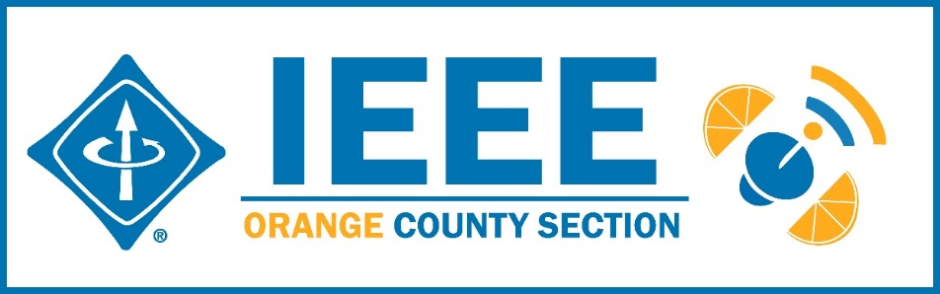
Minutes – IEEE Orange County Section Executive Committee Meeting
DATE: | Thursday 7-9-2020
TIME: | 6:30 PM – 8:30 PM
LOCATION: | On-line

- Networking 6:00pm-6:30pm
  - Meet-n-greet / Food on your own / Sign-in -
- Call Meeting to Order – 6:30pm
  - Secretary Quorum Status – Secretary _9 Attendees: Members, Guests
  - Groups represented: YPs, VTS, CS, GameSIG, Nano, PSES, EMBS
  - Introduction of attendees (if time permits) –
  - Approve Minutes from previous month(s) – Approved
http://sites.ieee.org/ocs/section-meeting-minutes/
  - Approve Agenda – Approved
- Section Business
  - Chairman’s opening remarks – Sections Congress Cancelled for 2020
  - 2021 Goals statement:
  - Follow up Action Items from last meeting(s)
    - Gora to regularly highlight chapters who have not reported –
    - Sponsor package –
    - Reminder to file L31 & financial reports – Gora listed open reports on vtools
    - - Gora planning IEEE tools training on line July 8 – Done and attended by folks outside the Section. Will attempt to put slide deck on website.
    - Note: IEEE offers Membership Development Webinars that are worth attending to improve chapter operations.
  - Treasurer’s report
    - Section Ledger – IEEE Rebates received. Distribution algorithm needs to be established and presented next month. Ad payment received for e-lynx ad.
    - Outstanding Funding Requests – None
    - New OC Section logo bumper stickers 3”x 5” available now – send Nick your mailing address
    - IEEE Region 6 Awards - Call for Nominations. Inviting all members to review and submit nominations for the IEEE Region 6 Awards.
https://ieee-region6.org/2020/call-for-nominations-ieee-region-6-awards-now-open/
Send nominations to Vice Chair, Alberto.
Categories can be Corporate Service, Student Branch, Outstanding Engineer, Best Chapter,… Deadline is Sept 15 but please do before.

- Event Updates (Check www.e-lynx.org or search the web for the event or click the link for more info)
  - IEEE Day
  - IEEE Sections Congress – Voting on issues to be done on line – Vice Chair Alberto is assigned to vote on behalf of the Section.
IEEE Section Congress 2020 - Orange County Section Representative Selection
https://sections-congress.ieee.org/

  - Sustech conf update: To be held On Line 4/22-24/2021
** Planning for 2021 Sustech is in early stages – this may be an OC spearheaded event and volunteers are needed to participate. Organizing committee meets 5PM every Friday – join in. Contact Gora

- OC Section and Committee Reports
  - Membership Development (MD) –– NEED an active person
It was suggested to have a “Life Members cameo region on the section website and solicit submissions from the sections’s Life Members.
  - Corporate Relations – Michael Fahey –
Past note: Suggestion taken to compile a list of companies, with CSUF help, to be used at a future career fair or for employment seeking purposes.
In collaboration with UCI Continuing Education thinking of compiling a list of IEEE subject matter experts who could serve as CE instructors.
  - Educational Activities – Kumar
  - STEM Initiatives – .Kumar –
  - Web events calendar www.e-lynx.org – Advertiser / Distribution updates – Nick- current advertisers include: ETAP 2020, IEEE TECH TALK Banner – Podcasts from IEEE experts. Manufacturing Show. UCI Extension Withdrew. K & S paid Job “ad” event.

- University Student Branch Report
  - California State University Fullerton (CSUF) –
  - University of California, Irvine (UCI) –
  - Chapman University –

- Affinity Groups
  - Women in Engineering (WiE) –
  - Young Professionals (YP) – Irvin – Raspberry Pi related event?
  - CyberSecurity SIG – (Gora)
  - GameSIG - – Goal is to expand nationwide

- OC Chapters & Society Activities
  - Aerospace & Electronics Systems Society (AESS) – Chapman Ramesh Singh - attempt to re-energize?
  - Communications Society /Signal Processing Society-Jt. VTS (COMSIG) / VTS – Kay
        - The Connected Vehicle Newsletter ver. 8 just published
  - Computer Society (CS) – Shirley – ACM meets Wednesday – 7/15
  - Electromagnetic Compatibility Society (EMC) –
  - Engineering in Medicine and Biology Society (EMBS) – Gora -.4th Tuesday events – Planning underway for a speaker/event in the near future.
  - Microwave Theory Tech / Electron Dev Jt Society(MTT/ED) –
  - Joint Foothill/OC Sections Nanotechnology Council Chapter – Nick – Events in future may go on line to allow students from all university locations to attend at once
  - Power and Energy Society/Industry Applications Society (PES/IAS) –
  - Product Safety Engineering Society (PSES) – Paul - 4th Tuesday events on hold.
  - Robotics & Automation Society (RAS)
  - Solid State Circuits –
  - LMAG –

- IEEE National, Region, & Council Updates
  - IEEE Southern California Council (ISC2) – UPDATE----
    - IEEE “TECH Talks” Speaker Forum – Gora – Conference in the works: Healthcare Blockchain& AI. Will have speakers, podcasts, workshops, …
    - IEEE USA Gov’t Relations Committee –
    - A larger funding proposal (from IEEE) is in process
  - IEEE Foundation Activities: EPICS And GLOBE Labs (EAGL)": Brian

- New Business
  - New Funding Requests –
**
NEXT MEETTING – August 13, 2020

