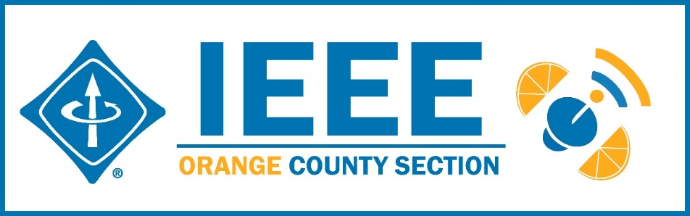
Minutes – IEEE Orange County Section Executive Committee Meeting
DATE: | Thursday 6-11-2020
TIME: | 6:30 PM – 8:30 PM
LOCATION: | On-line

- Networking 6:00pm-6:30pm
  - Meet-n-greet / Food on your own / Sign-in -
- Call Meeting to Order – 6:30pm
  - Secretary Quorum Status – Secretary 15_Attendees: 15 Members, 0 Guests
  - Groups represented: YPs, Computer Society, UCI, Chapman, Signal Processing/VTS, Nano 42, Product Safety, GameSIG
  - Introduction of attendees (if time permits) – Done
  - Approve Minutes from previous month(s) – Done
http://sites.ieee.org/ocs/section-meeting-minutes/
  - Approve Agenda – Done
- Section Business
  - Chairman’s opening remarks – Sections Congress Cancelled for 2020
  - 2021 Goals statement:
  - Follow up Action Items from last meeting(s)
    - Gora to regularly highlight chapters who have not reported –
    - Sponsor package –
    - Reminder to file L31 & financial reports – Gora listed open reports on vtools
    - - Gora planning IEEE tools training on line July 8
    - Note: IEEE offers Membership Development Webinars that are worth attending to improve chapter operations.
  - Treasurer’s report
    - Section Ledger –
    - Outstanding Funding Requests – None
    - New OC Section logo bumper stickers 3”x 5” available now – send Nick your mailing address

- Event Updates (Check www.e-lynx.org or search the web for the event or click the link for more info)
  - Sustech conf update: To be held On Line 4/22-24/2021

** Planning for 2021 Sustech is in early stages – this may be an OC spearheaded event and volunteers are needed to participate. Organizing committee meets 5PM every Friday – join in. Contact Gora

- OC Section and Committee Reports
  - Membership Development (MD) – Mike Fahey –
  - Corporate Relations – Michael Fahey –
Past note: Suggestion taken to compile a list of companies, with CSUF help, to be used at a future career fair or for employment seeking purposes.
In collaboration with UCI Continuing Education thinking of compiling a list of IEEE subject matter experts who could serve as CE instructors.
  - Educational Activities – Kumar
  - STEM Initiatives – .Kumar –
  - Web events calendar www.e-lynx.org – Advertiser / Distribution updates – Nick- current advertisers include: ETAP 2020, IEEE TECH TALK Banner – Podcasts from IEEE experts. Manufacturing Show. UCI Extension Withdrew

- University Student Branch Report
  - California State University Fullerton (CSUF) –
  - University of California, Irvine (UCI) – Nathan – Collaborating with UCLA to bring “Open Project Spaces” Program to UCI. UCLA used this program to increase IEEE Membership. The Student Chapter Board is planning workshops which will run at school when it reopens.
  - Chapman University – Brandon – Planning to produce I min videos with the School of Engineering on interesting topics and topics in research at the School. Planning on line workshops – using Discourse Hosting.

- Affinity Groups
  - Women in Engineering (WiE) –
  - Young Professionals (YP) – Irvin – May go on line with a Raspberry Pi related event
  - CyberSecurity SIG – (Gora)
  - GameSIG - Bill – Goal is to expand nationwide and beyond next year when the event will be at Chapman as well as on line.

- OC Chapters & Society Activities
  - Aerospace & Electronics Systems Society (AESS) – Chapman Ramesh Singh There was discussion of an attempt to re-energize this dormant chapter because there are a reasonable number of members in the SoCal area.
  - Communications Society /Signal Processing Society-Jt. VTS (COMSIG) / VTS – Kay Das, - Version 7 of Newsletter going up on section site. Vehicle AI software is finding a home in CoVID Track and Trace.
  - Computer Society (CS) – Shirley – ACM meets Wednesday – Next one to be July
  - Electromagnetic Compatibility Society (EMC) –
  - Engineering in Medicine and Biology Society (EMBS) – Gora -.4th Tuesday events – Planning underway for a speaker/event in the near future.
  - Microwave Theory Tech / Electron Dev Jt Society(MTT/ED) –
  - Joint Foothill/OC Sections Nanotechnology Council Chapter – Nick – Events in future may go on line to allow students from all university locations to attend at once
  - Power and Energy Society/Industry Applications Society (PES/IAS) –
  - Product Safety Engineering Society (PSES) – Paul - 4th Tuesday events on hold.
  - Robotics & Automation Society (RAS)
  - Solid State Circuits –
  - LMAG –

- IEEE National, Region, & Council Updates
  - IEEE Southern California Council (ISC2) – UPDATE----
    - IEEE “TECH Talks” Speaker Forum – Gora – Conference in the works: Healthcare Blockchain& AI. Will have speakers, podcasts, workshops, …
    - IEEE USA Gov’t Relations Committee –
    - A larger funding proposal (from IEEE) is in process
  - IEEE Foundation Activities: EPICS And GLOBE Labs (EAGL)": Brian

- New Business
  - New Funding Requests –
**
NEXT MEETTING – July 9, 2020

