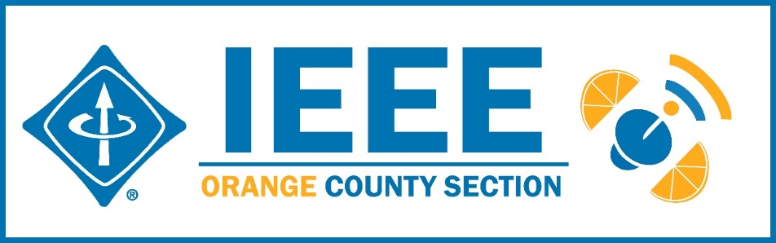
Minutes – IEEE Orange County Section Executive Committee Meeting
DATE: | Thursday 5-14-2020
TIME: | 6:30 PM – 8:30 PM
LOCATION: | On-line

- Networking 6:00pm-6:30pm
  - Meet-n-greet / Food / Sign-in - Done
- Call Meeting to Order – 6:30pm
  - Secretary Quorum Status – Secretary 12 _Attendees: 12 Members, 0 Guests
  - Groups represented: YPs, Nano, Communications, Computer Society, VTS, UCI, GameSIG, Chapman Student IEEE Chapter.
  - Introduction of attendees (if time permits) – Done
  - Approve Minutes from previous month(s) – Done
http://sites.ieee.org/ocs/section-meeting-minutes/
  - Approve Agenda – Done
- Section Business
  - Chairman’s opening remarks – The annual elections have been held
  - - 2021 Goals statement:
  - Follow up Action Items from last meeting(s)
    - Gora to regularly highlight chapters who have not reported –
    - Sponsor package – Mike and Gora to report
    - Reminder to file L31 & financial reports
  - Annual Section Officers Election –
Election completed. 98% votes in favor of Candidates:
Chair: Irvin Huang
V. Chair: Alberto Tam Yong
Sect’y: Nick Massetti
Treasurer: Gora Datta
  - Treasurer’s report
    - Section Ledger – Ledger reported out by Treasurer
    - Outstanding Funding Requests –
    - New OC Section logo bumper stickers 3”x 5” available now
- Event Updates (Check www.e-lynx.org or search the web for the event or click the link for more info)
  - Sustech conf update: held on line. 11 posters were presented Thursday, Papers presented Friday and Saturday all day. The related VTS workshop was cancelled.

** Planning for 2021 Sustech is in early stages – this may be an OC spearheaded event and volunteers are needed to participate. Organizing committee meets every Friday – join in

- OC Section and Committee Reports
  - Membership Development (MD) – Mike Fahey –
  - Corporate Relations – Michael Fahey –
Past note: Suggestion taken to compile a list of companies, with CSUF help, to be used at a future career fair or for employment seeking purposes.
In collaboration with UCI Continuing Education thinking of compiling a list of IEEE subject matter experts who could serve as CE instructors.
  - Educational Activities – Kumar UC Davis/OC Even postponed
  - STEM Initiatives – .Kumar –
  - Web events calendar www.e-lynx.org – Advertiser / Distribution updates – Nick- current advertisers include: ETAP 2020, IEEE TECH TALK Banner – Podcasts from IEEE experts. Manufacturing Show. UCI Withdrew

- University Student Branch Report
  - California State University Fullerton (CSUF) –
  - University of California, Irvine (UCI) – Nathan - New officers to be posted
  - Chapman University – Brandon and Arshia reported

- Affinity Groups
  - Women in Engineering (WiE) –
  - Young Professionals (YP) – Irvin – Events Pause underway.
  - CyberSecurity SIG – (Gora)
  - GameSIG - Winsor Brown reported… 15 team entrants, 10 games presented, over 130 viewers, very successful event, recorded. May be advantageous to connect up with SoCal Council for next year event.

- OC Chapters & Society Activities
  - Aerospace & Electronics Systems Society (AESS) – Chapman Ramesh Singh
  - Communications Society /Signal Processing Society-Jt. VTS (COMSIG) / VTS – Kay Das, gave keynote talk at Sustech2020
  - Computer Society (CS) – Shirley – ACM meets Wednesday – Talk 5/20 on mobile device security
  - Electromagnetic Compatibility Society (EMC) –
  - Engineering in Medicine and Biology Society (EMBS) –.4th Tuesday events
  - Microwave Theory Tech / Electron Dev Jt Society(MTT/ED) –
  - Joint Foothill/OC Sections Nanotechnology Council Chapter – Nick – 3/24 Event Postponed till Fall.
  - Power and Energy Society/Industry Applications Society (PES/IAS) – On Hold
  - Product Safety Engineering Society (PSES) – Paul - 4th Tuesday events on hold.
  - Robotics & Automation Society (RAS)
  - Solid State Circuits –
  - LMAG –

- IEEE National, Region, & Council Updates
  - IEEE Southern California Council (ISC2) – UPDATE----
    - IEEE “TECH Talks” Speaker Forum –
    - IEEE USA Gov’t Relations Committee –
    - A larger funding proposal (from IEEE) is in process
  - IEEE Foundation Activities: EPICS And GLOBE Labs (EAGL)": Brian

- New Business
  - New Funding Requests –
  - YP related expenses approved previously upon submission of related expense documents
**
NEXT MEETTING – June 11, 2020

