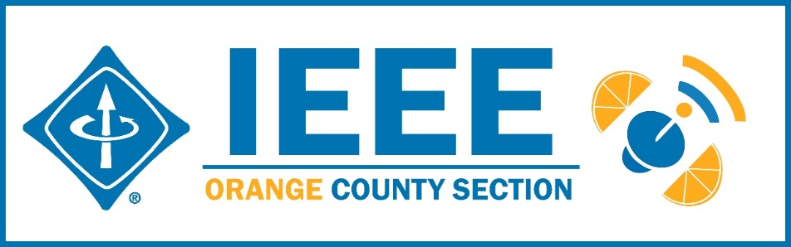
Minutes – IEEE Orange County Section Executive Committee Meeting
DATE: | Thursday March 12, 2020
TIME: | 6:30 PM – 8:30 PM
LOCATION: | 41 Tesla, Irvine

- Networking 6:00pm-6:30pm
  - Meet-n-greet / Food / Sign-in - Done
- Call Meeting to Order – 6:30pm
  - Secretary Quorum Status – Secretary 15_Attendees: 15 Members, 0 Guests
  - Groups represented: Game SIG, CS, Nano, UCI student, YP, Chapman Student, VTS, PSES,
  - Introduction of attendees (if time permits) – Done
  - Approve Minutes from previous month(s) – Done
http://sites.ieee.org/ocs/section-meeting-minutes/
  - Approve Agenda – Done
- Section Business
  - Chairman’s opening remarks – Chair and Vice Chair absent
  - - 2020 Goals statement:
  - Follow up Action Items from last meeting(s)
    - Gora to regularly highlight chapters who have not reported – Done
    - Sponsor package – Mike and Gora to report
    - Reminder to file L31 & financial reports
  - Annual Section Officers Election –
    - Raja
  - Treasurer’s report
    - Section Ledger – Ledger reported out
    - Outstanding Funding Requests – CS agreed to match $1250 funding by the OC Section for Game SIG event. Treasurer to pay out.
    - New OC Section logo bumper stickers distributed and reimbursed to Secretary.
- Event Updates (Check www.e-lynx.org or search the web for the event or click the link for more info)
  - Sustech conf update: OC Section to co-sponsor (Apr 23-25, 2020)..
Student posters may be included.
Steering Committee has a few open positions. If interested, talk to Charlie Jackson (Chair) or Gora Datta Also Irvin Huang is the Chair in charge of Social Media Outreach –
Location @ DoubleTree by Hilton Hotel Santa Ana – Orange County Airport
201 E MacArthur Blvd, Santa Ana, CA 92707.

** Student posters encouraged due to large prizes to be awarded
** Planning for 2021 Sustech is in early stages – this may be an OC spearheaded event and volunteers are needed to participate.

- OC Section and Committee Reports
  - Membership Development (MD) – Mike Fahey –
  - Corporate Relations – Michael Fahey –
Past note: Suggestion taken to compile a list of companies, with CSUF help, to be used at a future career fair or for employment seeking purposes.
In collaboration with UCI Continuing Education thinking of compiling a list of IEEE subject matter experts who could serve as CE instructors.
  - Educational Activities – Kumar 2020 International Conf – Volunteers are needed to help OC get involved. Kumar & Shirley Tseng on committee, looking for judges and all types of volunteers.
  - STEM Initiatives – .Kumar –
  - Web events calendar www.e-lynx.org – Advertiser / Distribution updates – Nick- current advertisers include: UCI Continuing Education. ETAP 2020, IEEE TECH TALK Banner – Podcasts from IEEE experts. Manufacturing Show.

- University Student Branch Report
  - California State University Fullerton (CSUF) –
  - University of California, Irvine (UCI) – Workshops underway. Mathworks, Drones,signal processing, Hackathon, SPAC planning with other schools
  - Chapman University – New student chapter restarted, officers elected. Datafest to be 1st weekend in May.

- Affinity Groups
  - Consultant’s Network (CN) -
  - Women in Engineering (WiE) –
  - Young Professionals (YP) –Robert updated on activities
Boba nights ongoing, maybe a mixer – family robot event
  - CyberSecurity SIG – (Gora)
  - GameSIG - Colleen reported – Event to go online, teams submit games.

- OC Chapters & Society Activities
  - Aerospace & Electronics Systems Society (AESS) – Chapman Ramesh Singh
  - Communications Society /Signal Processing Society-Jt. VTS (COMSIG) / VTS –
  - Computer Society (CS) – Shirley – ACM meets Wednesday –
  - Electromagnetic Compatibility Society (EMC) –
  - Engineering in Medicine and Biology Society (EMBS) –.4th Tuesday events
  - Microwave Theory Tech / Electron Dev Jt Society(MTT/ED) –
  - Joint Foothill/OC Sections Nanotechnology Council Chapter – Nick – CPP 3/24 Doc candidate Wang- 5G circuits POSTPONED
  - Power and Energy Society/Industry Applications Society (PES/IAS) –
  - Product Safety Engineering Society (PSES) – Paul - 4th Tuesday events ongoing
  - Robotics & Automation Society (RAS)
  - Solid State Circuits –
  - LMAG –

- IEEE National, Region, & Council Updates
  - IEEE Southern California Council (ISC2) – UPDATE----
    - IEEE “TECH Talks” Speaker Forum –
    - IEEE USA Gov’t Relations Committee –
    - A larger funding proposal (from IEEE) is in process
  - IEEE Foundation Activities: EPICS And GLOBE Labs (EAGL)": Brian

- New Business
  - New Funding Requests –
**
  - IEEE OC Section Logo – The Logo was added to the section website
  - 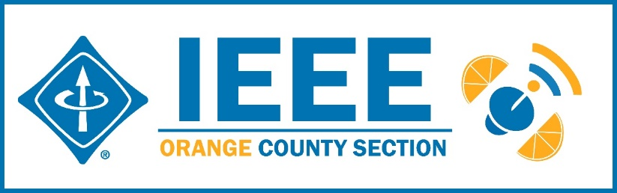
  - Elections – Section elections

NEXT MEETTING – April 9, 2020 41 Tesla, Irvine

