DATE: | Thursday February 13, 2020
TIME: | 6:30 PM – 8:30 PM
LOCATION: | 41 Tesla, Irvine

Minutes – IEEE Orange County Section Executive Committee Meeting

- Networking 6:00pm-6:30pm
  - Meet-n-greet / Food / Sign-in -
- Call Meeting to Order – 6:30pm
  - Secretary Quorum Status – Secretary YES _Attendees: 13 Members, 0 Guests
  - Groups represented: YP, CSUF, UCI, GameSIG, PSES, CyberSIG, NANO
  - Introduction of attendees (if time permits) – Done
  - Approve Minutes from previous month(s) – Done
http://sites.ieee.org/ocs/section-meeting-minutes/
  - Approve Agenda – Done
- Section Business
  - Chairman’s opening remarks –
  - - 2020 Goals statement:
  - Follow up Action Items from last meeting(s)
    - Gora to regularly highlight chapters who have not reported – Done
    - Sponsor package – Mike and Gora to report
    - Reminder to file L31 & financial reports for year 2020 NOW.
  - Annual Section Officers Election –
    - Raja will send out the call for nominations this month (Feb)
  - Treasurer’s report
    - Section Ledger – Gora verbally reported section balances.
    - Outstanding Funding Requests – CSUF to provide receipts to Rising Stars expenses and section treasurer to reimburse.
- Event Updates (Check www.e-lynx.org or search the web for the event or click the link for more info)
  - Feb 22, IVC location – IET Young Professionals competition
  - Sustech conf update: OC Section to co-sponsor (Apr 23-25, 2020)..
Student posters may be included.
Steering Committee has a few open positions. If interested, talk to Charlie Jackson (Chair) or Gora Datta Also Irvin Huang is the Chair in charge of Social Media Outreach –
Location @ DoubleTree by Hilton Hotel Santa Ana – Orange County Airport
201 E MacArthur Blvd, Santa Ana, CA 92707.

** Student posters encouraged due to large prizes to be awarded
** Planning for 2021 Sustech is in early stages – this may be an OC spearheaded event and volunteers are needed to participate.

- OC Section and Committee Reports
  - Membership Development (MD) – Mike Fahey – Nothing to report
  - Corporate Relations – Michael Fahey – Oracle approached about sponsorship of Oracle workshop and Datafest
Past note: Suggestion taken to compile a list of companies, with CSUF help, to be used at a future career fair or for employment seeking purposes.
In collaboration with UCI Continuing Education thinking of compiling a list of IEEE subject matter experts who could serve as CE instructors.
  - Educational Activities – Kumar 2020 International Conf – Volunteers are needed to help OC get involved. Kumar & Shirley Tseng on committee, looking for judges and all types of volunteers.
  - STEM Initiatives – .Kumar –
  - Web events calendar www.e-lynx.org – Advertiser / Distribution updates – Nick- current advertisers include: UCI Continuing Education. ETAP 2020, ADDED IEEE TECH TALK Banner – Podcasts from IEEE experts. New advertiser – Manufacturing conference.

- University Student Branch Report
  - California State University Fullerton (CSUF) – Doing Micromouse, Bionic arm, spiderbot
  - University of California, Irvine (UCI) – Doing Micromouse, Keysight workshop, microcontrollers event
  - Chapman University – (No report) – New school of engineering starting up. – Organizational meeting to be held 2/14/2020

- Affinity Groups
  - Consultant’s Network (CN) -
  - Women in Engineering (WiE) –
  - Young Professionals (YP) – Irvin -
Boba nights ongoing, maybe a mixer – family robot event
  - CyberSecurity SIG – (Gora) Event at Webster U
  - GameSIG -

- OC Chapters & Society Activities
  - Aerospace & Electronics Systems Society (AESS) – Chapman Ramesh Singh
  - Communications Society /Signal Processing Society-Jt. VTS (COMSIG) / VTS –
  - Computer Society (CS) – Shirley – ACM meets Wednesday – 2/26 Oracle Workshop
  - Electromagnetic Compatibility Society (EMC) –
  - Engineering in Medicine and Biology Society (EMBS) –.4th Tuesday events
  - Microwave Theory Tech / Electron Dev Jt Society(MTT/ED) –
  - Joint Foothill/OC Sections Nanotechnology Council Chapter – Nick – CPP 3/24 Doc candidate Wang- 5G circuits
  - Power and Energy Society/Industry Applications Society (PES/IAS) –
  - Product Safety Engineering Society (PSES) – Paul - 4th Tuesday events ongoing
  - Robotics & Automation Society (RAS)
  - Solid State Circuits –
  - LMAG –

- IEEE National, Region, & Council Updates
  - IEEE Southern California Council (ISC2) – UPDATE---- Gora elected Chair, Coastal LA and Metro Sections approached about joining ISC2 –
    - IEEE “TECH Talks” Speaker Forum –
    - IEEE USA Gov’t Relations Committee – working on CA AB5 exemptions
    - A larger funding proposal (from IEEE) is in process
  - IEEE Foundation Activities: EPICS And GLOBE Labs (EAGL)": Brian

- New Business
  - New Funding Requests –
** CSUF reimbursement for Rising Stars expenses was paid: $573.27
** Game SIG to be awarded funding matching that provided by IEEE CS chapter not to exceed $1250.
** DataFest- a STEM event. Motion to grant $1000 was approved

  - IEEE OC Section Logo – we voted for a logo that has a satellite icon with two half orange slices as solar panels and the word ORANGE in Orange County Section colored orange. Final edits on this selection to be made by Irvin.
  - 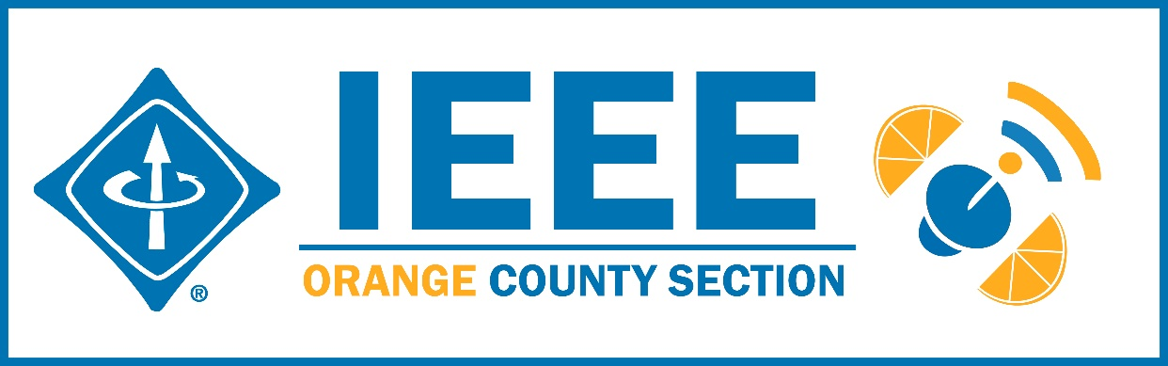
  - Elections – Section elections

NEXT MEETTING – March 12, 2020 41 Tesla, Irvine

